Delphi DocuPro
Automated Testing of form migrations
Summary

Delphi has developed an automated process for testing forms by toggling between the GhostDraft and Crystal versions for the forms for the same Policy transactions. This gives the users the ability to test in bulk and
- Do a side-by-side compare of the PDFs
- Compare performance of GhostDraft form against Crystal with the same Policy data
The script creates two sets of temporary tables to capture test Policy information. We then run a simple search for previous policy transactions based on forms types (so at least one of more GhostDraft form is included) and number of risks. In the first part of the test, the user sets the GhostDraft forms as active and runs the scripts that then re-processes these transactions to create a mixed bundle of GhostDraft and Crystal forms (depending on the config settings). The user then manually disables the GhostDraft version of forms and runs second part of the scripts that re-processes the forms, this time using the ALL Crystal versions.
Theses scripts maybe altered to suit any individual customized needs.
Steps/Scripts:

Steps | What | How | Scripts or Instructions
1 | Create new tables | Run Script | 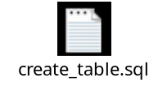
2 | Set required GhostDraft forms to active | Manual – Use OASIS Form Configuration tool OR SQL tools | In the os_form_interface table set the effective to and from dates for the required forms
3 | Populate new table with Policies transactions to regenerate forms | Run script to choose Policies based on criteria (Large Policies, number of Policies etc)  OR  Manually load table – Use SQL Tools | 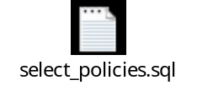  In the new Policy_info table enter Policy # and request_ids of transactions you wish to reprocess
4 | Regenerate transactions | Run script | 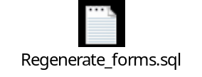
4.a | Submit Forms | If forms are set as End of Day then run script | 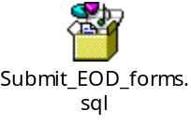
5 | Review the PDFs (GhostDraft forms), time to print etc. Save the PDFs to alternate Directory for compare against Crystal version (from next steps) | Manual | Time to complete can be obtained by using the earliest and oldest sys_create time for each request_id in the os_crystal trigger table and calculating the difference  Note: if a single request ID has a combination of GhostDraft and Crystal forms then ODS first processes ALL crystal forms for that request first and then GhostDraft
6 | Expire GhostDraft version of the forms | Manual – Use OASIS Form Configuration tool OR SQL tools | In the os_form_interface table set the effective to and from dates for the required forms
7 | Repeat Steps 4 and 5 |  | Review the time to process Crystal version of the forms and compare against time for Step 5

Note: Some other places where time spent can be gathered/analyzed are listed below:
- The CE Processing time column in the os_crystal_trigger table contains times as defined below:
  - For Crystal Forms, it’s the time spent by Crystal/BI to produce the PDF. The value is obtained from BI.
  - For DoucPro Forms, it’s the time spent by ODS between submitting the request to GhostDraft/Eloquence and getting response back from GhostDraft/Eloquence.
- The GhostDraft Administration Console has a monitoring report that averages the number of forms processing over time.
- When you have a mix of Crystal and DocuPro forms for a single form request ID, ODS processes the Crystal forms first and then moves to the DocuPro forms. The time stamp on the XML file (located in the Directory defined by the OASIS system parameter -os_xml_path) would indicate when the Ghostdraft forms begin processing in ODS.

